TPW - AT2
1 - TypeScript Language 1
1.1 - Variables Declaration 1
1.2 - Basic Types 1
1.3 - Functions 2
1.4 - Interfaces 3
1.5 - Classes 3
1.6 - Modules 5
2 - Introduction to Angular 6
3 - Angular Architecture 6
3.1 - Modules 6
3.2 - Components 7
3.3 - Metadata 7
3.4 - Template 7
3.5 - Data Binding 7
3.6 - Directives 8
3.7 - Service 8
3.8 - Dependency Injection 8
4 - Angular Developing 8
5 - Routing in Angular 9
6 - Multiple Views in Angular 9
7 - RESTful Web Services/Django REST framework 9
7.1 - Web Services: 9
7.2 - REST Web Services: 10
7.3 - Django REST framework (DRF): 10
8 - Services and Dependency Injection 10
8.1 - Services 10
8.2 - Services 11
8.3 - Dependency Injection - DI 11
8.4 - Observables 11

1 - TypeScript Language
TypeScript:
- A partir da mesma sintaxe e semântica do JS
- Pode usar code existente de JS, incorporar livrarias famosas do JS e o code pode ser chamado através do JS
- Compila para um clean e simples JS code que corre no browser, Node.js, etc.
- Value: Definir e usar Types p/ JS.
- Enable JS practices: static checking e code refactoring
- Types: Permite definir interfaces entre componentes software e dá mais controlo no comportamento das librarias de JS
- Types inference: code static verification a partir de annotations

1.1 - Variables Declaration
var x = 1; Deprecated because its flaw
let y = 2; New and strong declaration

const z = 3; Constants

let arr = [10, 20]; Array
let [a,b] = arr; Array destructuring

let o = {a:1, b:’hello’, c:10}; Dictionary
let {a,c} = o; Object destructuring

1.2 - Basic Types
Boolean:
- let isfull: boolean = true;
Number:
- let dec: number = 10.5; Decimal
- let hex: number = 0xFF; Hexadecimal
- let oct: number = 0o373; Octal
- let bin: number = 0b1010; Binary
String:
- let name: string = ‘John’;
- name = ‘Jones’;
- let s: string = ‘Your name is: ${name}’;

Array:
- let list: number[] = [10,20,30];
- let list: Array<number> = [10,20,30];
Tuple:
- let t: [Boolean, number];
- t = [false, 100]; OK
- t = [100, false]; ERROR
enum:
- enum Color {red, green, blue}
- let c: Color = Color.green;
any:
- let what: any = 100;
- what = true; OK
void (nothing, oposto de any):
- let nothing: void = null; or undefined
- normally used for return type of a function
null and undefined:
- null is the absence of a value in a variable
- undefined is the absence of definition of a variable
never:
- type of values that never occur
- usually used as function type for never ending functions
type assertion (caste like):
- let avalue: any = “this is a string value”;
- let slength = (<string>avalue).length;

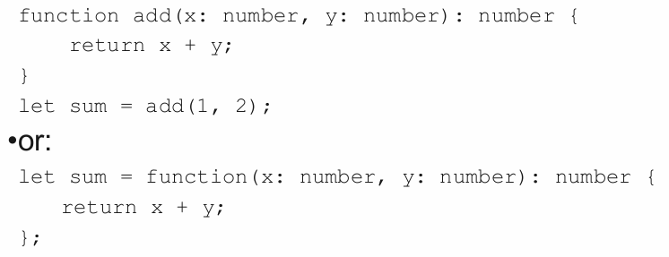
1.3 - Functions
Podem ser criadas como named functions ou como funções anonimas e typed

Defining function types:
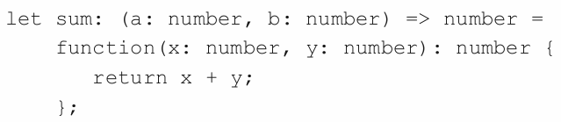
- Function typing includes two parts: parameters and return type
No exemplo: a funcção, para ser usada, tem de ter 2 parametros of type number and a return type of type number.
Optional parameters:
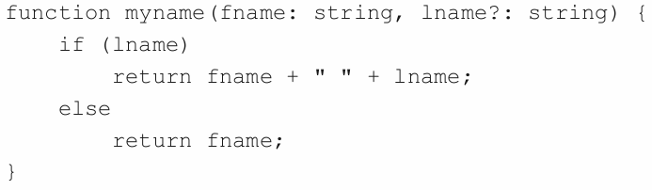
Default parameters:
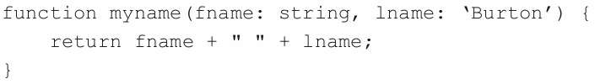
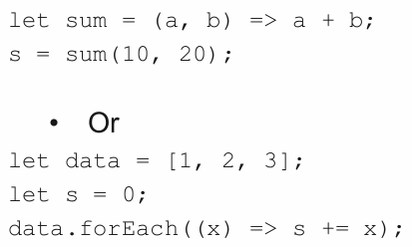
Fat Arrow Functions:
- Way to write functions in a shorthand notation.

1.4 - Interfaces
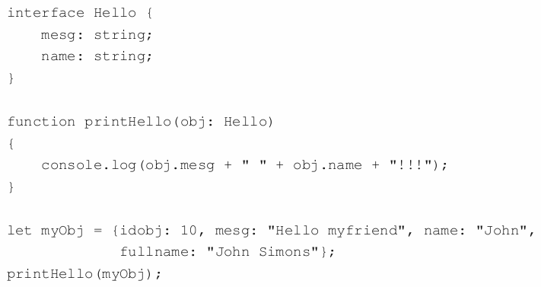

1.5 - Classes
- TypeScript allow developers to use object-oriented techniques and approaches, based on classes, to program their web scripts.
- It compiles down to JS that works across all major browsers and platforms, without having to wait for the next version of JS

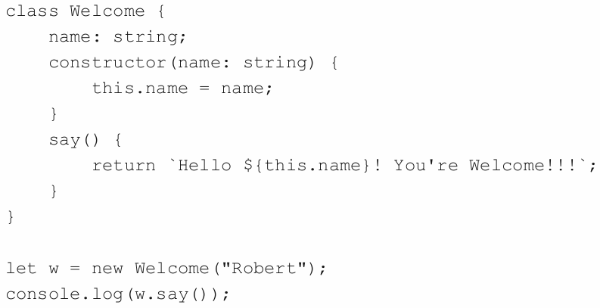
Classes - Inheritance
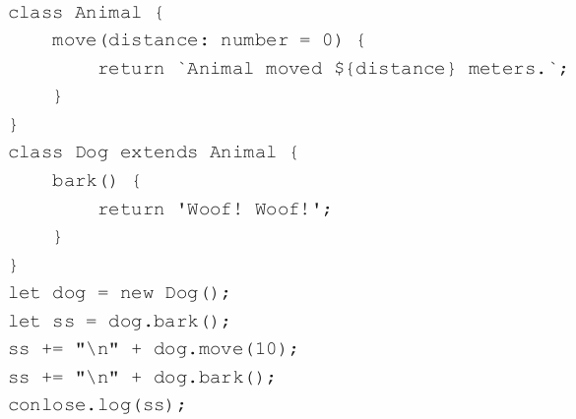
Classes - Overloading
Example 1:
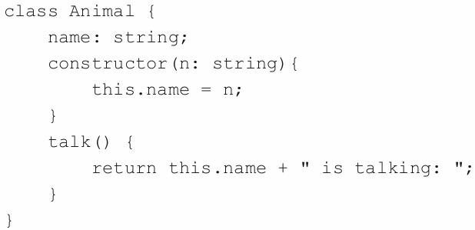
Example 2:
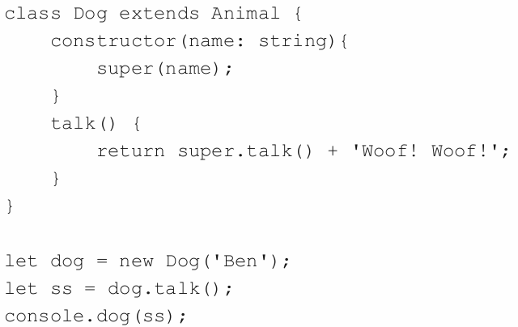

1.6 - Modules
Modules are executed within their own scope, not in the global scope.
Variables, functions, classes, etc. declared in a module are not visible outside the module.
Modules are declarative – the relationships between modules are specified in terms of imports and exports at the file level.
In TypeScript, any file containing a top-level import or export is considered a module.
Conversely, a file without any top-level import or export declarations is treated as a script whose contents are available in the global scope.
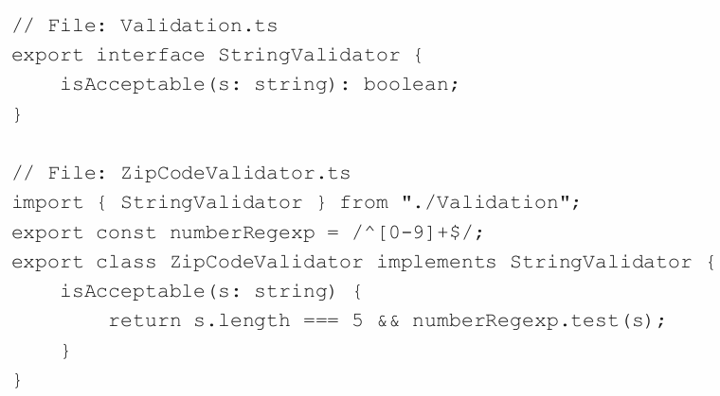

2 - Introduction to Angular
Angular:
- Baseado em TypeScript
- Components-Based Web Development Approach
- Permite construir web apps out of components, que são UI building blocks que são fáceis de testar e reusar.
- Components, neatly encapsulate all the style and function required for a certain feature to work, and so, creating custom HTML elements is a greatly simplified process.
- The idea is to build declarative components that are fully encapsulated.
- They describe their own views, and can be easily packaged and distributed to other developers.
- The application itself consists of a root component that contains a set of components for every UI element, screen, and route.
- This component tree lies at the core of any Angular application.

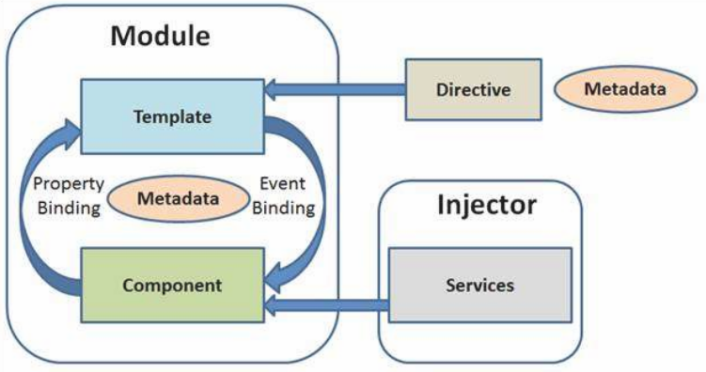
3 - Angular Architecture

3.1 - Modules
Block of code wich is designed to perform a single task
Can be exported in form of a class.
Angular apps can have multiple modules, but must have at least one.
Angular apps have one root module and can have many more featured modules.
Angular module is a class which uses the @NgMudolue decorator.
Decorators provide a way to add both annotations and a meta-programming syntax for class declarations and members.
@NgModule takes a single metadata object and its properties to describe the module
Properties of @NgModule:
- exports – it’s the subset of declarations which would be used in the component template of other module.
- imports - imports other modules
- providers - It is a creator of services. They can be accessible in all the parts of the application.
- bootstrap - The root module has to set the bootstrap property. It is used to host all other views.
- declarations - It declare the view class that belong to current module. There are three types of view classes supported by Angular: components, directives, and pipes.

3.2 - Components
Component is the combination of a class, containing the core logic for a page, and a an associated template that deals with its View.
- The application logic is written inside the class which is used by the View. The class interacts with the View through methods and properties of its API.
- Angular creates and updates the required components, and destroys the unused ones as the user moves through an application.

3.3 - Metadata
Metadata is the way to define how Angular process a class, a method or a property, for particular reasons.
In TypeScript, metadata is defined by using decorators.
For example, if we want to define a component in an Angular application, we need to tell Angular that a particular class is a component.
- This is done associating metadata to the class using @Component decorator.

3.4 - Template
A template is the component View that tells Angular how to display the component.

3.5 - Data Binding
Data binding is a powerful feature of software development technologies. It is the connection bridge between View and the business logic of the application.
4 types of data binding supported by Angular:
- Interpolation - used to display the component value within HTML.
- Property Binding - It passes the property’s value of a parent component to its child’s property.
- Event Binding – used to fire an event when we click on a component’s name, or some change occurs in an input component.
- Two-way Binding – it combines event and property binding in single notation by using ngModel directive, in order to have automatic change between the data model and the view.

3.6 - Directives
Directives extend HTML attributes. These are markers on the DOM elements which provides some special behavior to them and tell Angular HTML compiler to attach it.
3 types of directives:
- Decorator Directive - it decorates (@Directive) the elements using additional behavior. There are many built-in directives like ngModel, and others.
- Component Directive - it is extended from @Directive decorator with template-oriented features.
- Template Directive - it converts HTML into a reusable template. It is also known as structural directive.

3.7 - Service
A service is a broad category encompassing any value, function, or feature that an app needs.
A service is typically a class with a narrow, well-defined purpose.
Angular distinguishes components from services in order to increase modularity and reusability.
Typical examples of services are logging service, data service, message service etc. And there is no base class to define a service.

3.8 - Dependency Injection
Dependency Injection is a software design pattern in which objects are passed as dependencies. It helps us remove the hard coded dependencies, and makes dependencies configurable.
Using Dependency Injection, we can make components more maintainable, reusable, and testable.
Dependency Injection (DI) is wired into the Angular framework and used everywhere to provide new components with the services or other things they
need.

4 - Angular Developing
Ver pdf aula 10.

5 - Routing in Angular
The Angular Router is based on this model:
- It can interpret a browser URL as an instruction to navigate to a client-generated view.
- It can pass optional parameters along to the supporting view component that help it decide what specific content to present.
- You can bind the router to links on a page and it will navigate to the appropriate application view when the user clicks a link.
- You can navigate imperatively when the user clicks button, selects from a drop box, or in response to some other stimulus from any source.
- And the router logs activity in the browser's history journal so the back and forward buttons work as well.
Routing - Developing
Ver pdf aula 11

6 - Multiple Views in Angular
Adding multiple views:
- Adding an Overview panel.
- Adding the ability to navigate between Authors and Overview views.
- When users click an author in either view, it navigates to a details view of the selected author.
- When users click a deep link in an email, it opens the details view for a particular author.
Ver pdf aula 11

7 - RESTful Web Services/Django REST framework

7.1 - Web Services:
- Web services are services offered by electronic devices to send data to another electronic devices, using web technologies.
- Normally, data is transmitted in JSON or XML format.
- One of the main purposes of web services is to provide interoperability and data integration between heterogeneous information systems.

7.2 - REST Web Services:
REST – Representational State Transfer
- It’s an architectural model for hypermedia applications, mainly used for web services implementation, which are considered to be light, simple, sustainable and scalable.
- A service based on this technology is named as RESTful Service.
- REST services don’t depend on any particular protocol, however most of them use HTTP for transporting.
- Another kind of web services are the SOAP Web Services. These are based on the SOAP protocol, which is very formal, strict and heavy. That’s why it’s not often used.

7.3 - Django REST framework (DRF):
DRF is a python library to create REST Web Services integrated with Django framework.
It provides an important set of functions for ease programming this kind of services, as:
- The possibility to publish the provided API;
- Authentication policies, using OAuth1a and OAuth2 protocols;
- Data serialization from DBs, through Django ORM or other means;
- It can use general views if advanced facilities aren’t needed;
- Currently, it’s used by big organizations (Mozilla, Red Hat, etc.), what proves its credibility.
Ver pdf 12a code

8 - Services and Dependency Injection
A component should not need to define things like:
- how to fetch data from the server; validate user input; or log directly to the console.
Ideally, its job is to enable the user experience and nothing more. It must present properties and methods for data binding, in order to mediate between the view and the application logic.
Instead, it should delegate such tasks to other type of processors, named Services in Angular.

8.2 - Services
A Service is a broad category encompassing any value, function, or feature that an app needs.
A service is typically a class with a narrow, well-defined purpose. It should do something specific and do it well.
By defining that kind of processing task in an injectable service class, you make it available to any component.
Apps can also be more adaptable by injecting different providers of the same kind of

8.3 - Dependency Injection - DI
Dependency injection (often called DI) is wired into the Angular Framework and used everywhere to provide new components with the services or other things they need.
Components consume services; that is, a service can be injected into a component, giving the component access to that service class.
To define a class as a service in Angular, it uses the @Injectable decorator to provide the metadata that allows Angular to inject it into a component as a dependency.

8.4 - Observables
Angular's HttpClient methods return RxJS Observables.
Observables provide support for passing messages between publishers and subscribers in your application.
They offer significant benefits over other techniques for event handling, asynchronous programming, and handling multiple values.
Observables are declarative - that is, you define a function for publishing values, but it is not executed until a consumer subscribes to it. The subscribed consumer then receives notifications until the function completes, or until they unsubscribe.

Creating a service - ver pdf aula 12b

